Smart Traffic Light System using IR Sensor and Arduino

Project Report

IN

Master of Computer Application

Submitted by

Gurpreet Kaur

Submitted to
Mr. Gaurav Mehta
(E14354)



UNIVERSITY INSTITITUET OF COMPUTING, CHANDIGARH UNIVERSITY GHARUAN, MOHALI-140413, PUNJAB, INDIA

April 2026

Acknowledgement
I wish to express my sincere thanks to my project guide, Mr. Gaurav Mehta, for his guidance and support throughout the completion of this project. His insightful suggestions helped me refine the project scope and encouraged me to delve deeper into the subject matter. I also want to extend my gratitude to the HOD, University Institute of Computing for providing an academic atmosphere conducive to learning. Finally, I would like to thank my friends and family for their unwavering support throughout this project

Date:10.04.2026
Place: Chandigarh University, Mohali, Punjab
Gurpreet kaur
UID:- 24MCA20094

Abstract
The rapid increase in vehicles on roads has created a need for efficient traffic management systems. Traditional traffic light systems operate on fixed time intervals, which often leads to unnecessary delays, traffic congestion, and inefficient use of road infrastructure. To overcome these issues, this project presents a Smart Traffic Light System using Arduino and IR Sensor, which adjusts signal timing based on real-time vehicle detection.
In this system, an IR sensor is used to detect the presence of a vehicle at a particular lane. The sensor sends signals to the Arduino microcontroller, which processes the input and controls the traffic lights accordingly. If a vehicle is detected, the system increases the duration of the green signal to allow smooth traffic flow. In the absence of vehicles, the system follows a predefined timing sequence similar to conventional traffic signals.
Additionally, a buzzer is incorporated into the system to provide audible alerts during signal transitions, especially during red and yellow signals. This enhances safety and awareness for pedestrians and drivers.
The project is cost-effective, easy to implement, and demonstrates the practical application of embedded systems and automation. It also provides a foundation for further improvements such as integration with IoT, real-time monitoring, and smart city applications. Overall, this project highlights how technology can be used to improve traffic efficiency and reduce congestion in urban areas.

Aim
The main aim of this project is to design and develop a Smart Traffic Light System using Arduino that can automatically control traffic signals based on real-time vehicle detection. The project focuses on improving the efficiency of traffic management systems by reducing unnecessary waiting time and optimizing signal timing.
Another aim of this project is to demonstrate the use of sensors and microcontrollers in real-world applications. By using an IR sensor, the system can detect the presence of vehicles and make decisions accordingly. This helps in understanding how embedded systems can be used for automation and control.
The project also aims to provide a low-cost and simple solution that can be easily implemented in small-scale environments such as college projects, model demonstrations, and learning purposes. It helps students gain practical knowledge of electronics, programming, and system design.
Furthermore, the project aims to enhance safety by incorporating a buzzer that alerts users during signal transitions. It also encourages innovation by showing how traditional systems can be upgraded into smart systems using modern technology.

Objectives
The main objective of this project is to design a smart traffic control system that can efficiently manage traffic signals using real-time data from sensors. The project aims to move beyond traditional fixed-time traffic signals by introducing automation and adaptability.
One of the key objectives is to understand the working of the Arduino microcontroller and how it can be programmed to control multiple output devices such as LEDs and buzzers. This helps in developing practical knowledge of embedded systems and their applications.
Another important objective is to use an IR sensor for detecting the presence of vehicles. By doing so, the system can respond dynamically and increase the green signal duration when traffic is present. This reduces unnecessary waiting time and improves traffic flow.
The project also aims to implement a buzzer alert system that enhances safety by providing audio signals during traffic light transitions. This helps pedestrians and drivers to be more aware of signal changes.
Additionally, the project focuses on creating a simple, low-cost, and easy-to-implement system that can be used for educational purposes. It encourages learning through practical implementation and helps students understand the integration of hardware and software.
Finally, the project aims to test and verify the network by performing connectivity checks such as pinging between devices. This ensures that the network is functioning correctly and meets the desired requirements.
Tools and Technologies Used
🔧 Hardware Components (with Quantity)
The following components are used to build the Smart Traffic Light System:
- Arduino Uno → 1
- Traffic Light Module (3-in-1: Red, Yellow, Green LEDs) → 1
- IR Sensor Module → 1
- Buzzer (2-wire type) → 1
- Breadboard → 1
- Jumper Wires:
  - Male–Male → 5–6
  - Male–Female → 4–6
- USB Cable (Power Supply + Programming) → 1
🔌 Pin Configuration Table
The following table shows the connection of each component with Arduino:
Component | Arduino Pin
Red (R) | Pin 8
Yellow (Y) | Pin 9
Green (G) | Pin 10
Buzzer (+) | Pin 7
Buzzer (–) | GND
IR Sensor OUT | Pin 2
IR Sensor VCC | 5V
IR Sensor GND | GND
Traffic Module GND | GND

💻 Software Used
- Arduino IDE (for coding and uploading)
⚙️ Technologies Used
- Embedded Systems
- Sensor-based Automation
- Microcontroller Programming
- Real-time Control System
IMPLEMENTATION
The implementation of the Smart Traffic Light System is carried out in a structured and systematic manner. The process involves planning, circuit design, hardware setup, programming, and testing.
🔹 Step 1: Problem Identification
The first step is to identify the limitations of traditional traffic systems. Conventional traffic lights operate on fixed time intervals, which leads to unnecessary delays when there is no traffic. The aim is to develop a system that adapts to real-time conditions.
🔹 Step 2: System Design
A smart solution is designed using Arduino and sensors. The system includes:
- Traffic light module for signal display
- IR sensor for vehicle detection
- Buzzer for alert
- Arduino for control
The system is designed to increase green signal duration when traffic is detected.
🔹 Step 3: Component Collection and Testing
All required components are collected and tested individually:
- Arduino is tested using basic LED blink program
- IR sensor is tested for detection
- LEDs and buzzer are checked
This ensures that all components are working before assembly.
🔹 Step 4: Breadboard Power Setup
The breadboard is used to distribute power:
- Arduino 5V is connected to breadboard positive rail
- Arduino GND is connected to breadboard negative rail
This allows all components to share power easily.
🔹 Step 5: Traffic Light Module Connection
The traffic light module is connected to Arduino:
- Red → Pin 8
- Yellow → Pin 9
- Green → Pin 10
- GND → GND rail
This enables Arduino to control the traffic signals.
🔹 Step 6: Buzzer Connection
The buzzer is connected using jumper wires:
- Positive → Pin 7
- Negative → GND
The buzzer produces sound alerts during signal transitions.
🔹 Step 7: IR Sensor Connection
The IR sensor is connected as follows:
- VCC → 5V
- GND → GND
- OUT → Pin 2
The sensor detects vehicles and sends signals to Arduino.
🔹 Step 8: Writing the Program
The program is written in Arduino IDE. The code includes:
- Controlling LED sequence
- Reading sensor input
- Adjusting signal timing
- Activating buzzer
🔹 Step 9: Uploading the Code
The code is compiled and uploaded to Arduino using USB cable. Proper COM port and board selection are ensured before uploading.
🔹 Step 10: Testing the System
The system is tested by placing an object (hand) in front of the IR sensor:
- If detected → Green light duration increases
- If not detected → Normal sequence
🔹 Step 11: Debugging and Correction
Any errors in wiring or logic are corrected:
- Checking connections
- Adjusting sensor position
- Fixing code if needed
🔹 Step 12: Final Working
After successful testing, the system works properly:
- Displays traffic signals
- Detects vehicles
- Adjusts timing
Output
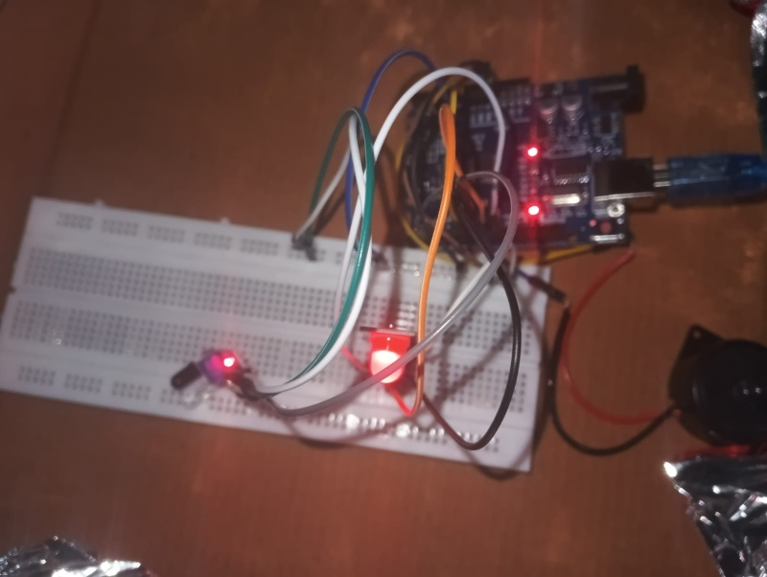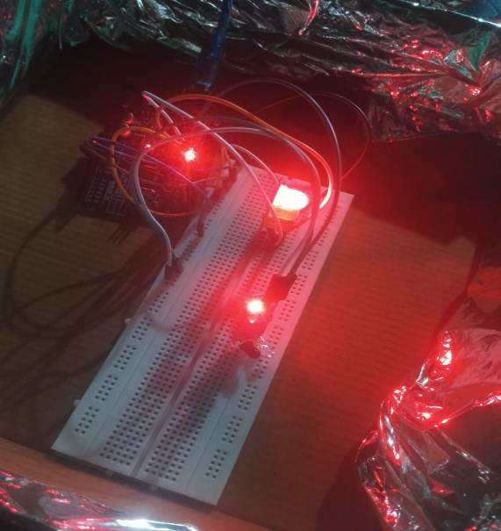
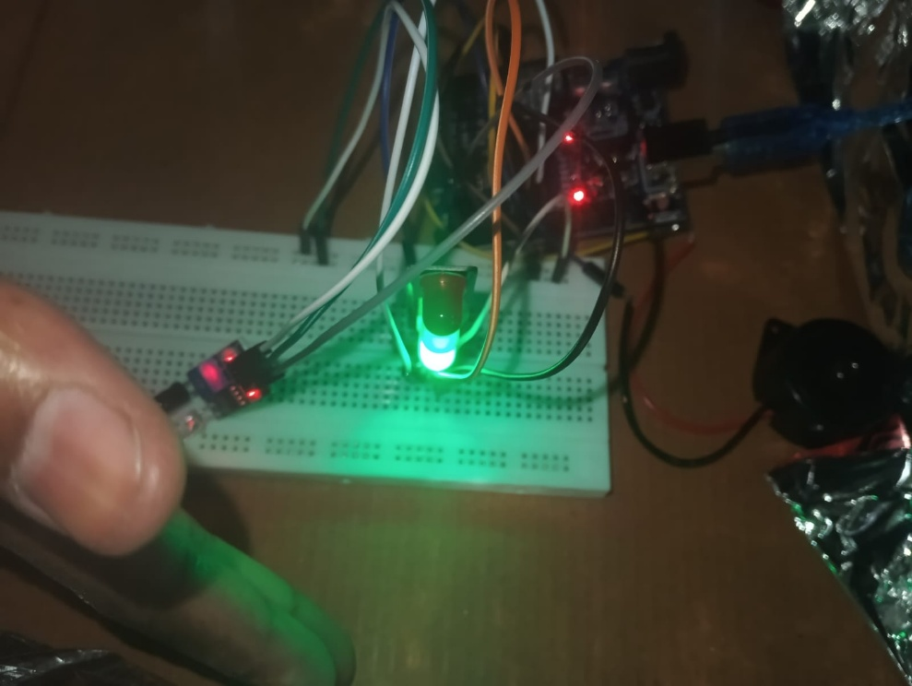
Conclusion
In conclusion, the smart traffic light system using Arduino and IR sensor provides an effective solution for improving traffic management. The project successfully demonstrates how traditional traffic systems can be enhanced using modern technology and automation.
The system is capable of detecting vehicles and adjusting signal timing accordingly, which helps in reducing unnecessary delays and improving traffic flow. The use of a buzzer adds an additional safety feature by alerting users during signal transitions.
This project is simple, cost-effective, and easy to implement, making it suitable for educational purposes and small-scale applications. It helps students gain practical knowledge of electronics, programming, and embedded systems.
Furthermore, the project has great potential for future improvements. It can be upgraded by integrating IoT technology for remote monitoring and control. Advanced sensors and AI algorithms can also be used to make the system more intelligent and efficient.
Overall, this project highlights the importance of smart systems in modern society and demonstrates how technology can be used to solve real-world problems.
References
The following resources were used during the development of this project:
- Arduino Official Website: https://www.arduino.cc
- Arduino IDE Documentation and Tutorials
- YouTube educational channels related to Arduino and IoT projects
- Electronics Hub (www.electronicshub.org)
- Circuit Digest (www.circuitdigest.com)
- Various online articles and blogs related to smart traffic systems
- College notes and study materials on embedded systems
These resources provided valuable information about Arduino programming, sensor interfacing, and circuit design. They helped in understanding the concepts and implementing the project successfully.

